**Primary Originator:**

**Name - Jasjeet Kaur**

**Student ID – 100363149**

**Reviewers:**

**Harneet Kaur (100365644)**

**Jasdeep Kaur (100359509)**

**Baljinder Kaur (100362124)**

***User Case Diagram of the Project:***

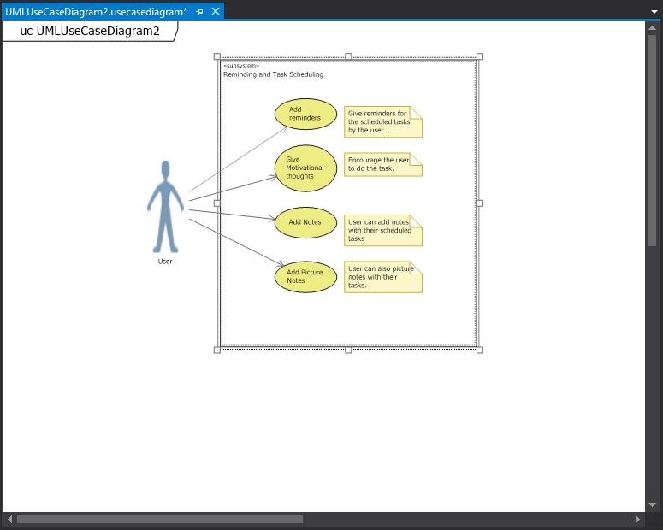

|  |
| --- |
| Use case title: Giving motivational thoughts |
| Primary Actors: User |
| Level: Kite(summary) |
| Stakeholders: User |
| Precondition: Get the application from any playstore. |
| Minimal Guarantee: At least they will be able to get the reminders. |
| Success Guarantee: Along with reminders, Users will be able to get motivational thoughts. |
| Trigger: Users will be able to access the application. |
| Main Success Scenario:   1. Users will able to open the motivational thoughts tab. 2. Getting motivational thoughts for the scheduled tasks of the day. |
| Extensions:   1. Users will not able to open the motivational thoughts tab.   1a. Users will quit the app.   1. Users will not able to get the motivational thought.   2a. Users will quit the app.  2b. Users can try to use another tab  2c. Users can get the reminders without the motivational thought. |

***Use Case Description:***